MY PRACTICE SHEET
JUNIOR KG
THEME WORKSHEET
NAME: DATE: 19.1.2024

PAPERY PARROT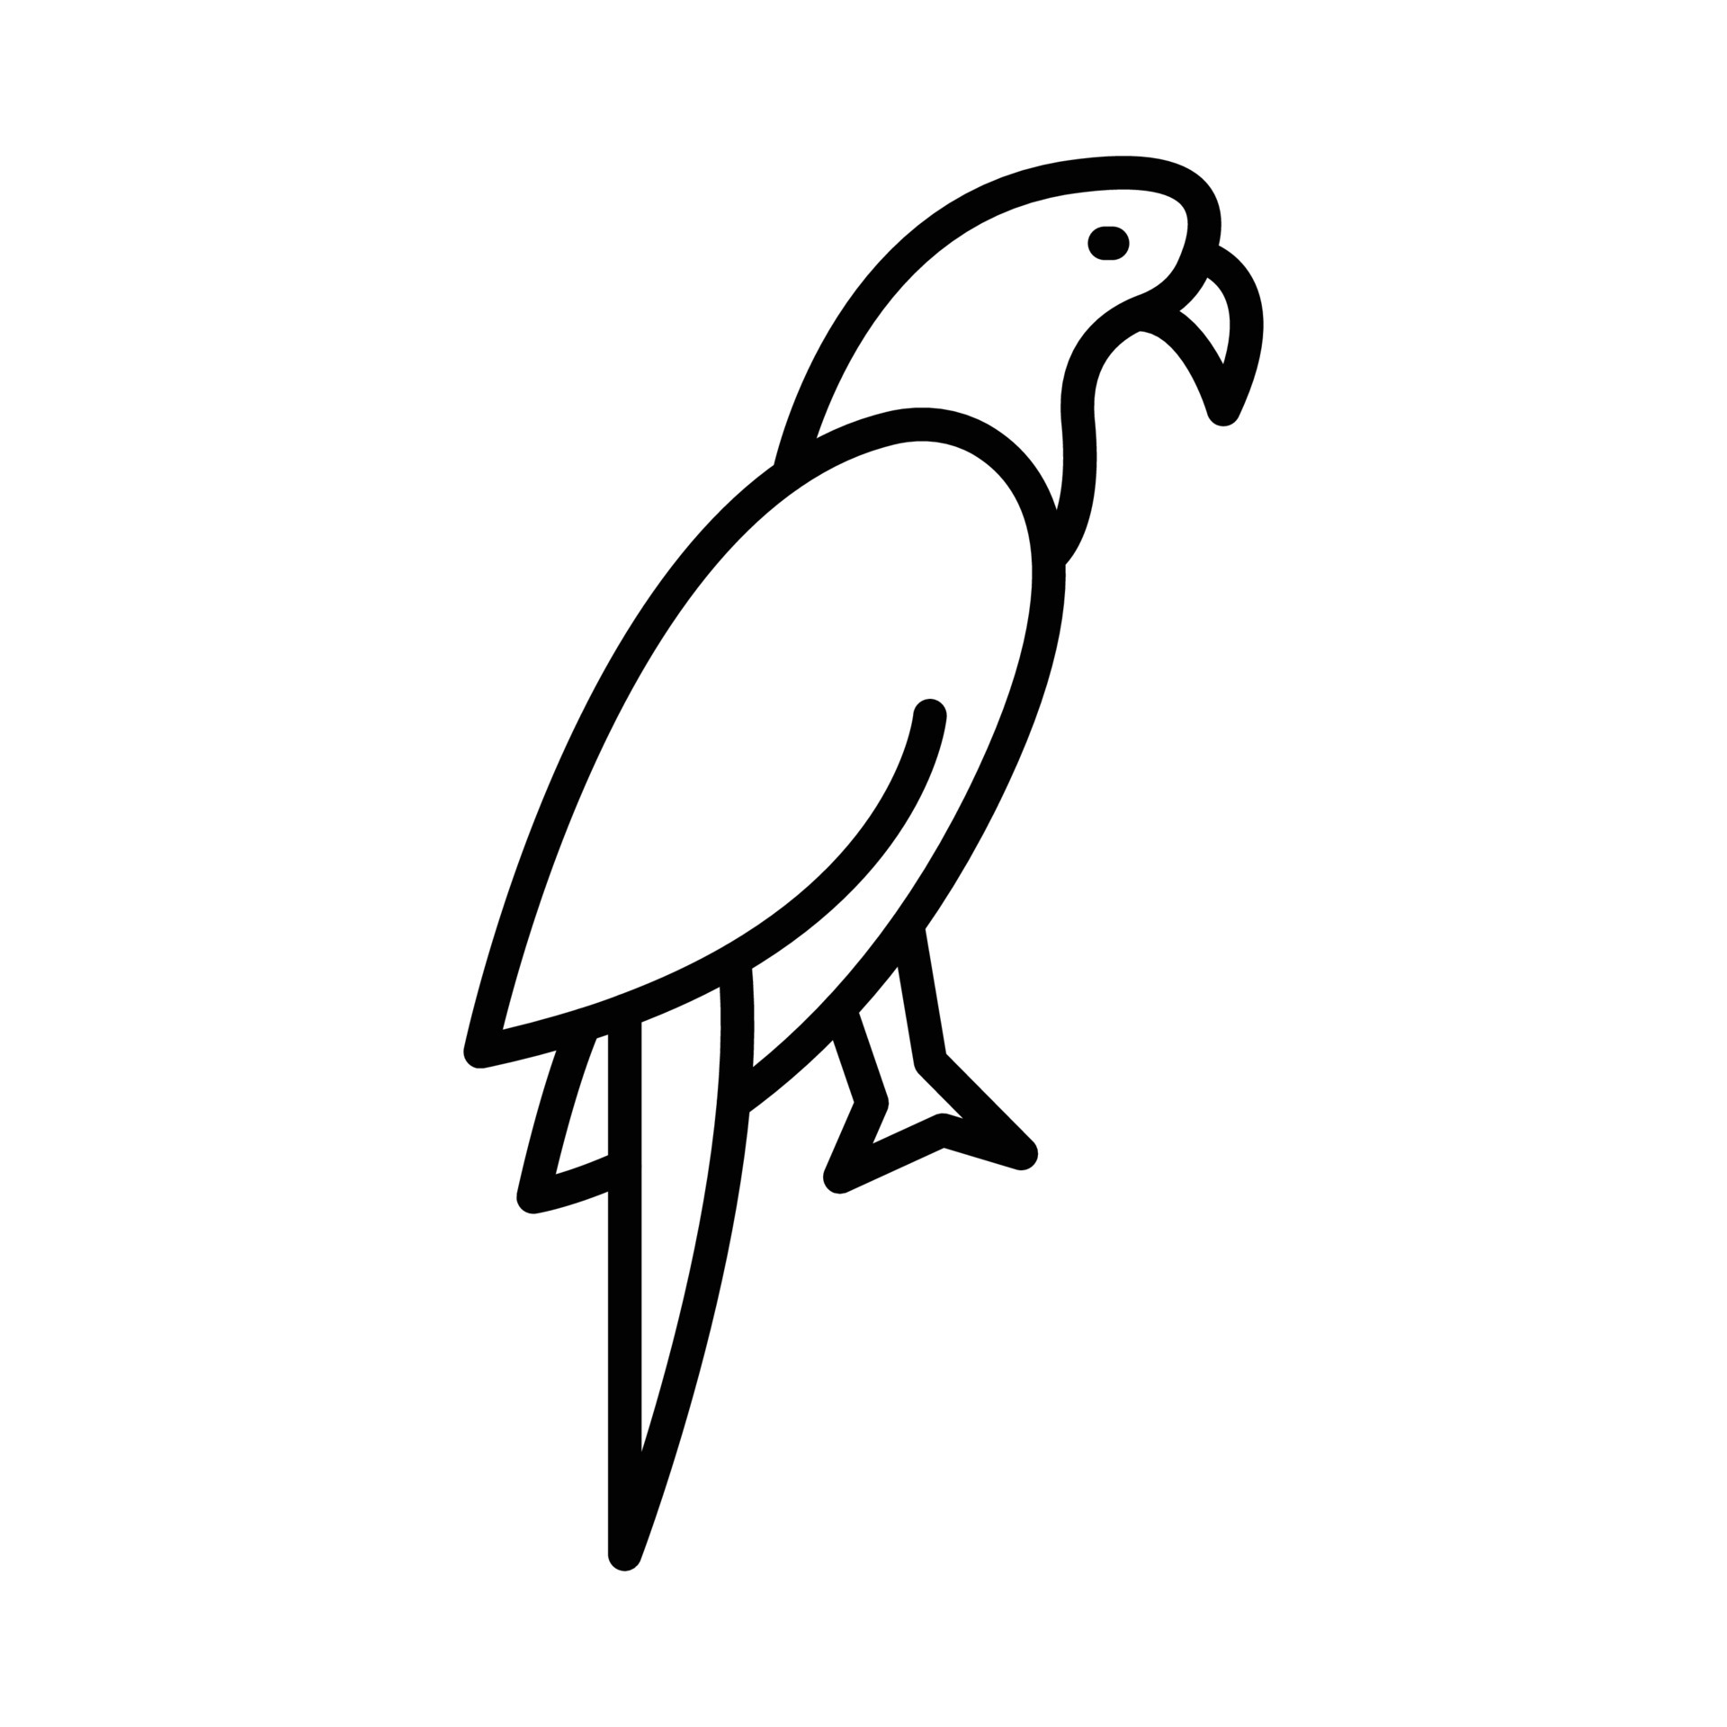

TR. SIGN REMARKS

MY PRACTICE SHEET
JUNIOR KG

NAME: DATE: 07.12.2023

Color the monitor, keyboard and mouse:
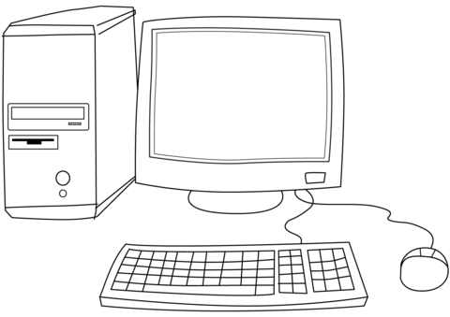

TR. SIGN REMARKS

